
Creativity using Crazy Eight Technique
Ajibola Abraham Olusola-oke
Supervisor: Bruce Power

Introduction and Problem Statement

Many creative professionals face pressure to generate creative and user-centred solutions in tight deadlines while collaborating with team members. Crazy Eight Ideation technique solves this problem, it’s an eight-minute paper sketching technique that forces out eight distinct brainstorming ideas from each team member (one minute each for each idea) afterwards the team will analyse and select the best ideas together. Traditional ideation methods usually struggle to come up with rapid divergent and convergent thinking ideation suitable for teams, especially in remote work environments. The Crazy Eight technique, popularized by Google Ventures Design Sprint methodology (Knapp et al., 2016), has emerged as a powerful rapid ideation tool that challenges participants to generate eight different design solutions in eight minutes, from initial ideas to pushing beyond their creative boundaries.
Even though crazy eight is very effective in face-to-face team exercises, several gaps remain in understanding how to adequately implement divergent and convergent ideation in Crazy Eight exercises, and how it can be performed for distributed teams. Current challenges include: (1) inefficient divergent-convergent cycles where teams fall-back to familiar solutions through premature convergence (Cropley, 2006); (2) collaboration barriers as traditional face-to-face sketching workshops fail to translate to digital environments (Bressa et al., 2019); (3) skill and technical barriers creating participation inequities for team members with limited artistic confidence; and (4) time pressure creating stress that may impede some participants (Sowden & Dawson, 2011).

While many existing literatures examine sketching in design, rapid prototyping, and design sprints, limited research specifically optimizes the Crazy Eight technique for distributed teams. Few digital tools address the unique requirement of time-limit by using reminders, best practices guidelines, preparation on the sketching exercises with integrated evaluation workflow at the end. Providing an effective theoretical and practical understanding of Crazy Eight exercise for physical and remote teams.

Aim and Objectives

This project aims to investigate the Crazy Eight technique as an effective ideation method for creative and non-creative professionals to collaborate on ideas without any technical barriers. This research also aims to help distributed teams to conduct, participate in, and evaluate Crazy Eight sessions effectively.

Specific objectives include:

1. Conduct comprehensive literature review examining the Crazy Eight technique, including relationships to divergent/convergent thinking, design collaboration, constraints-based creativity, and rapid prototyping.

2. Comparison between physical and online/digital crazy eight exercise to reveal their strengths, weaknesses and when to effectively know their use-case.

3. Build a digital solution for crazy eight exercises, that will be used to examine the comparison of the differences between physical and digital crazy eight exercise.

Methodology
This project employs agile methodology, due to the size of the development team (which is just me), the need for feedback from my first and second reader project-supervisors, and the time allocated for the project. When the theoretical investigation is on-going, the iterative development of the solution will be built alongside the research. The agile methodology iterations will ensure the solution adapts to the market change, prioritization if delays occur, early participant recruitment, and clear MVP definition, which is suitable for a solo development like this.

Data Collection
Data collection will be a survey that involves adult creative professionals like designers, UI/UX professionals and project managers (non-creatives). Participants will be screened to exclude individuals with high stress-sensitive conditions like hypertensive participants.

Ethical Analysis
This research strictly follows the university ethical guidelines with the privacy and safety of every participant in mind. Time pressure may cause stress for the participants; mitigation includes clear warnings, pre-screening/questioning for hypertension/anxiety disorders, withdrawal rights, optional time restart, and post-session guidance. Consent form covers research purpose, data collection methods, withdrawal rights, risks, and benefits.
Data privacy measures include participant anonymity (by pseudonymization), GDPR compliance, and no user data storage. Sketches may contain proprietary information; protection includes zero user data storage of user’s sketches. Intellectual property: participants retain individual ownership; organizations own collective outputs; research use covered in consent information.
Inclusivity promoted through diverse recruitment, multiple instruction inputs, assistive technology testing, and avoiding artistic skill requirements for non-technical participants. Primary risks: stress from time pressure (Medium severity - mitigated through screening and optional restart of the exercise), data breach (High severity – zero data storage and access controls), performance anxiety (Low severity - emphasis on quantity over quality), technical barriers (Low severity - no artistic requirements), and confidential information exposure (Medium - clear guidance and NDAs).

Time and Resources Plan
The project spans 31 weeks from January to August 2026, structured around university milestones

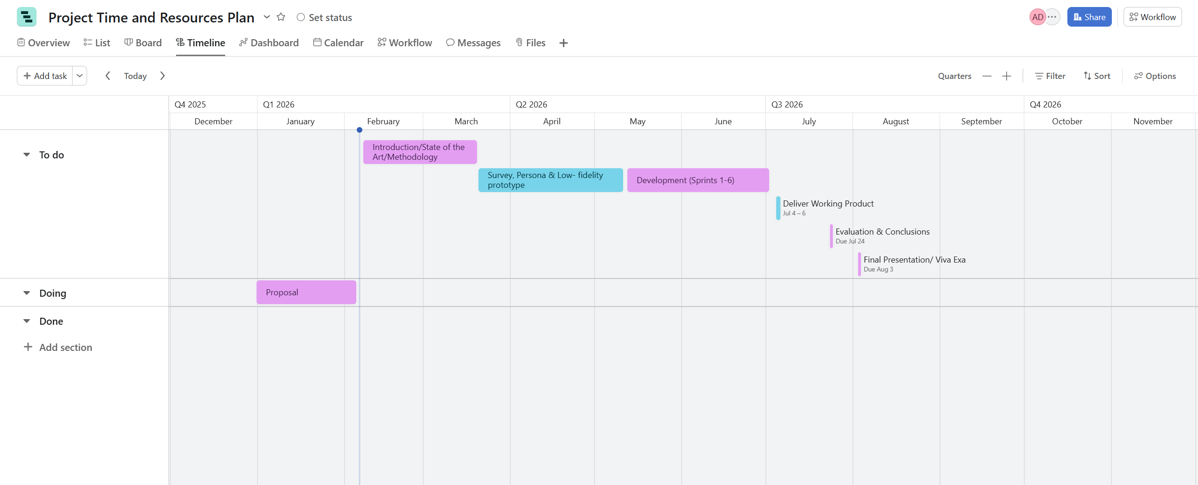
Figure 1: Project Timeline Gantt Chart for Crazy Eight Ideation Research

Deliverables: Proposal (1000 words, due 6 February 2026). Introduction/State of the Art/Methodology (3000 words, due 20 March 2026). Design & Implementation with artifact (2500 words, due 26 June 2026). Evaluation & Conclusions (2500 words, due 24 July 2026). Poster/Viva (on 3 August 2026).

Expected Outcomes
Theoretical contributions include empirical evidence for Crazy Eight effectiveness in creative professional contexts, understanding of time constraint impact on creative output, comparison between paper and digital Crazy Eight exercises, and implementation of a solution for Crazy Eight in distributed environments, which will be used for comparison. Practical contribution will include functional digital solution for Crazy Eight sessions guidelines, best practices recommendations, and accessibility options. Beneficiaries include creative professionals like UI/UX professionals (with enhanced ideation capabilities), non-creatives like managers and product teams (to improve creative processes and non-technical team collaboration), educators (evidence-based resources), and organizations (effective innovation processes).

References
Bressa, N., Wannamaker, K., Korsgaard, H., Willett, W., & Vermeulen, J. (2019). Sketching and ideation activities for situated visualization design. In Proceedings of the 2019 on Designing Interactive Systems Conference (pp. 173-185).
Cropley, A. (2006). In praise of convergent thinking. Creativity Research Journal, 18(3), 391-404.
Knapp, J., Zeratsky, J., & Kowitz, B. (2016). Sprint: How to solve big problems and test new ideas in just five days. Simon and Schuster.
Sowden, P. T., & Dawson, L. (2011). Creative feelings: The effect of mood on creative ideation and evaluation. In Proceedings of the 8th ACM Conference on Creativity and Cognition (pp. 393-394).

